Components (Parts) of a Server response

🔹 What are the Components (Parts) of a Server Response?
# Source: Chatgpt (GPT-5-Mini) at [1/16/2026]
When a server replies to a client’s request, it sends a server response, which contains several parts that describe the result of the request and any returned data.

✅ Main Components of an HTTP Server Response:
# Source: Chatgpt (GPT-5-Mini) at [1/16/2026]
Component | Description | Example
1. Status Line | Tells the client the result of the request | HTTP/1.1 200 OK
2. Headers | Metadata about the response | Content-Type: text/html
3. Body (Optional) | The actual data/content returned to the client | HTML, JSON, image, etc.
4. Protocol Version | Version of HTTP used | HTTP/1.1, HTTP/2

🔍 Breakdown of Each Part:

1. Status Line
# Source: Chatgpt (GPT-5-Mini) at [1/16/2026]
- Shows:
  - HTTP version
  - Status code (e.g., 200, 404)
  - Status message (e.g., OK, Not Found)
📘 Example:
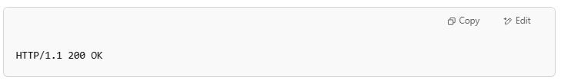
HTTP/1.1 200 OK

2. Response Headers
# Source: Chatgpt (GPT-5-Mini) at [1/16/2026]
- Key-value pairs that describe the response.
- Examples:
  - Content-Type: application/json (format of the body)
  - Content-Length: 348 (size of body)
  - Set-Cookie: sessionId=abc123 (used for managing sessions)
  - Cache-Control: no-cache (tells browser not to store this data)

3. Response Body (optional)
# Source: Chatgpt (GPT-5-Mini) at [1/16/2026]
- Contains the actual data requested by the client (if applicable).
- Formats:
  - HTML (for web pages)
  - JSON or XML (for API data)
  - Image or file (binary data)
📘 Example (JSON):
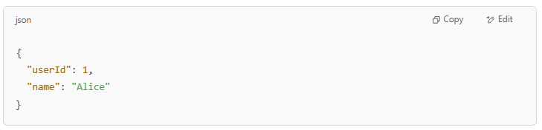
{
"userId": 1,
"name": "Alice"
}

4. Protocol Version
# Source: Chatgpt (GPT-5-Mini) at [1/16/2026]
- Specifies the HTTP version used for the response.
- Example: HTTP/1.1, HTTP/2

🧠 Example Full HTTP Server Response:
# Source: Chatgpt (GPT-5-Mini) at [1/16/2026]
HTTP/1.1 200 OK
Content-Type: application/json
Content-Length: 59
Connection: keep-alive

{
"message": "Login successful",
"userId": 42
}

Let me know if you'd like to see how this looks in a real browser or through code (like using fetch in JavaScript).

